
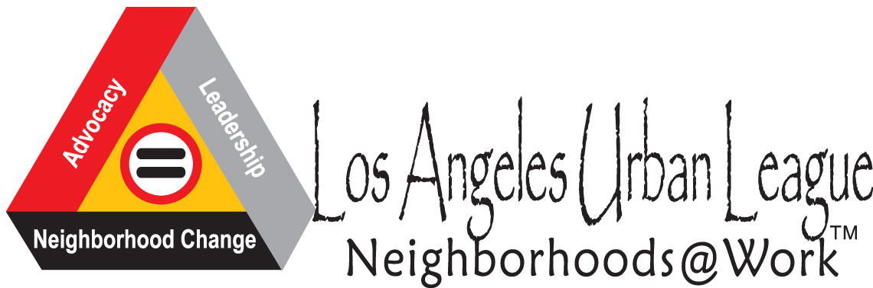
Census 2010 Student Public Service Announcement (PSA) Contest

Make a difference in our community for the upcoming 2010 Census!!!
*It’s not too late to join the project!*


- Prizes for ALL participants!
- Mentoring from industry professionals!
- Publicity/ recognition for your PSA!
- Build Industry Connections!
- Service Learning Credit!
- Gain experience in video production!
- Priority for summer jobs!
- Refreshments at all project sessions in the Studio!

PSA’s will be judged on the following criteria:
- Message- How well does it show why it is important to complete the census questionnaire?
- Impact- How strongly does it get the point across?
- Creativity- How fresh, new, and innovative is it?
- Best Overall- The PSA excels in all of these areas
- Language- The best PSA’s in a language other than English

The contest is for Media, Art & Design Academy students. All workshops will take place at Crenshaw High School in room #S-03 (The Studio).

There will be four phases of this contest-
- Phase 1: Education
  - workshop #1- Wednesday, February 10, 2010 3:15-5:15
  - workshop #2- Thursday, February 11, 2010 3:15-5:15
- Phase 2: Contest Launch and Writing of PSA
  - Workshop #1- Wednesday, February 17, 2010 3:15-5:15
  - Workshop #2- Thursday, February 18, 2010 3:15-5:15


- Phase 3: Filming of PSA
  - Workshop #1- Wednesday, February 24, 2010 3:15-5:15
  - Workshop #2- Thursday, February 25, 2010 3:15-5:15
- Phase 4: Post Production of PSA- February 26th -March 5th

***Additional use of equipment is available***

State-wide Census PSA Contest deadline- TBD
PSA Contest Reception, sponsored by the Los Angeles Urban League- TBD

Please contact Ms. O’Leary for additional information
Room#S-06 e-mail- ms.k.oleary@gmail.com
Census in the Schools-

Public Service Announcement Contest

The Los Angeles Urban League is sponsoring a Public Service Announcement (PSA) contest here at Crenshaw High School. As students of color, you live in hard to count areas. This PSA contest provides you with an interactive learning opportunity about a vital civic responsibility that you will hopefully carry with you into adulthood; thus, breaking the cycle of traditional low response rates for your demographic. Additionally, the work you create will educate and inspire all those who come to the website to learn about the 2010 Census and vote for their favorite PSA. Your work will encourage friends and family to watch the videos, which we hope will increase participation, since there is a high probability that these individuals are also from hard to count communities.

This contest puts youth in a leadership position, empowering them to be our educators and our motivators as we move forward with the challenge of counting all Californians. Students will be able to compete in a local PSA contest sponsored by the Los Angeles Urban League, as well as a state-wide contest. Students will have the opportunity to work with professional writers and actors throughout this process. In addition, we hope that we will be able to secure local media to air the winning Crenshaw H.S. Census PSA.

